Pasmore, Victor (1908 – 1998)

Born in Chesham, Surrey, in 1908, Victor Pasmore became one of the most influential British abstract artists after the Second World War, although prior to the war his paintings were representational and strongly influenced by post-impressionism. Then in 1937 he co-founded the Euston Road School of realist painting with Claude Rogers, Graham Bell and William Coldstream. Soon after the war he began experimenting with abstraction and by 1950 had abandoned realism for abstract works involving geometric imagery. From 1951 to 1955, Pasmore was the central figure in the Constructionist group of abstract artists, most of whom went on to pursue lifetime careers in the broad constructivist tradition. He was appointed Head of Painting at Durham University in 1953, and Consulting Director of Urban Design for the New Town of Peterlee in 1954 where he designed the modernist Apollo Pavilion. Later, he adopted a less geometric form of abstraction. He represented Britain at the 1960 Venice Biennale, became a Trustee of the Tate Gallery in 1963 and was elected a Royal Academician in 1983. He died in Malta in 1998, where he had been living since 1966.

Pasmore’s early work consisted mainly of landscapes and still lifes. He soon gained a reputation as a talented young artist and had his first one-man exhibition in London in 1933. Tentative pre-war experimentation in abstraction proved unsatisfactory and instead, with the Euston Road school, he turned to realistic depictions of everyday life. Pasmore taught at the school, though Euston Road also became a loose knit group of some 30 artists who painted in a realist style. The school closed in 1939.

After the war, dissatisfied with all forms of representational painting, he again explored abstraction, eventually deciding on a constructivist approach, involving the building-up of an image by the assemblage of basic geometric elements into an aesthetically satisfying whole. Pasmore’s conversion to abstraction was described by Herbert Read as “the most revolutionary event in post-war British art”. By 1951 he had established contact with other like-minded artists (Kenneth and Mary Martin, Anthony Hill, Robert Adams) and formed a group which became known as the Constructionists. Pasmore’s growing reputation led to his senior appointment at Durham University and as design consultant to Peterlee New Town, where he advised on road layouts and house styles as well as designing the Apollo Pavilion as a visual focus point in the town landscape. His work with architects reflected his view at that time that constructive abstract art contributed to a unity of purpose between painting, sculpture and architecture.

In the years after his move to Malta in 1966 he gradually abandoned this constructivist approach, ceased making three dimensional reliefs and returned to painting and the production of screenprints which, while still wholly abstract, displayed a more fluid and colourful imagery. He was, though consistent throughout his long career in promoting the concept of abstract imagery as deriving internally from the mind, rather than being abstracted from the shapes and colours of nature.

List of key works

- The Quiet River: the Thames at Chiswick, oil on canvas, Tate
- Square Motif: Blue and Gold, oil on canvas, Tate
- Abstract in White, Black, Indian red and Lilac, wood relief, Tate
- Abstract in White, Green, Black, Blue, Red, Grey and Pink, perspex and
wood relief, Tate
- Apollo Pavilion, Peterlee New Town
- Space, Time and Four Dimensions, oil on board, Tate

References and Further Reading

Herbert Read in Brion, M., ed., Art Since 1945, New York, 1959

Grieve, Alastair, ed., Victor Pasmore, London, 2010
Grieve, A., Constructed Abstract Art in Britain, New Haven & London, 2005
Bowness A. and Lambertini L., Victor Pasmore, London, 1980

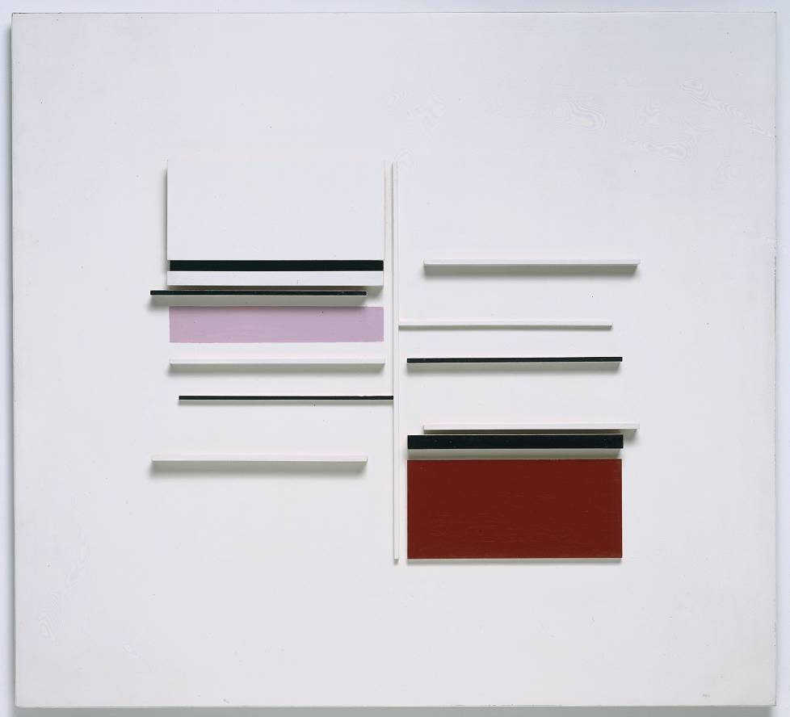
Victor Pasmore, Abstract in White, Black, Indian red and Lilac, 1957, painted wood, 106.7 x 116.8 cms, Tate

www.tate.org.uk/art/artworks/pasmore-abstract-in-white-black-indian-lilac-t00166

